**Connecting to an existing repository on GitHub**

* Go to <https://github.com>
* Create an account
* Open Ruby Mine
* Select GitHub as shown in below image  
  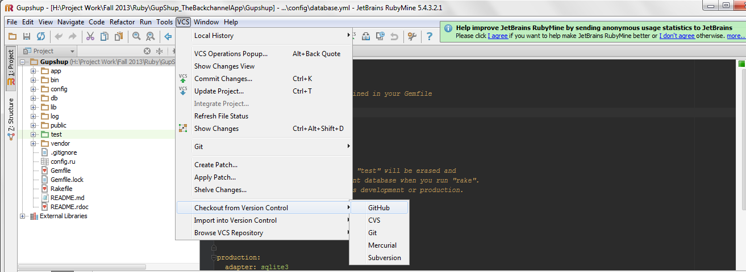
* It will ask for your username and password. Setup your git account with your credentials.
* Create a folder on your machine for the project. Name it say BackApp
* Open windows command line and cd to that folder. Run below command.

git clone <https://github.com/mihirvj/Gupshup.git> <your folder name>

*Disclaimer: There may be various ways to do it but I like it this way!* ☺

* The above step will fetch all the existing data into your folder. If you don’t provide your folder name in command, it will create its own folder named Gupshup so don’t worry about it.
* Now open RubyMine. Select File -> Open Directory and open your directory.
* This should do it. You may encounter some problem because I am not cloning the repo as I am writing this doc and I may have missed something.